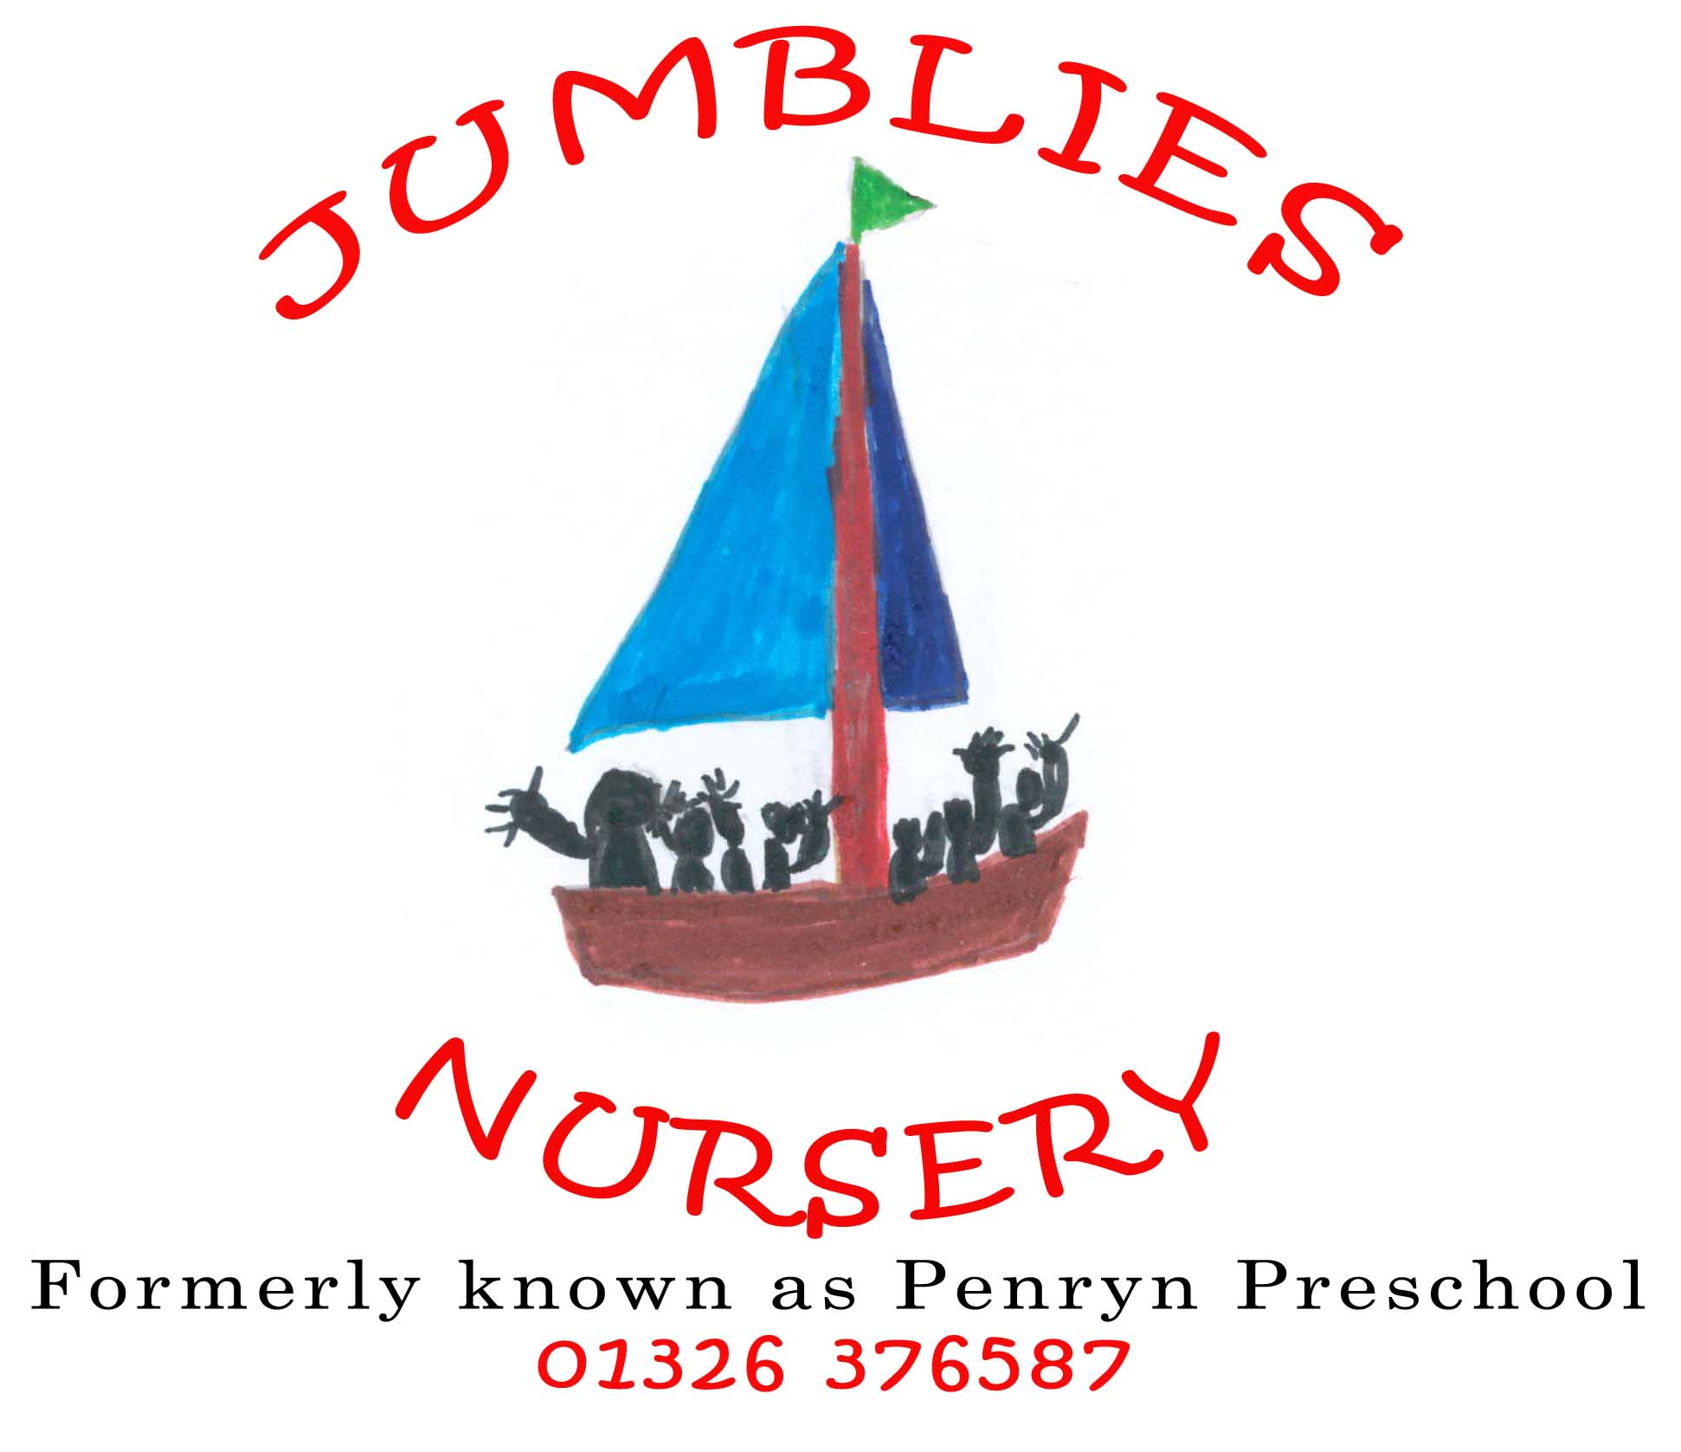
To be signed by parent/carer

Parental Consent Form for ____________________ (child’s full name)

- Permission for emergency medical treatment
I agree to the person in charge of the Nursery taking the necessary steps to ensure my child receives the best and most appropriate care, attention and treatment should there be an emergency or accident in the Nursery or while my child is on an authorised outing.
I understand that every effort will be made to inform me as soon as possible after the event. Should this not be possible I authorise the person in charge of the Nursery to take my child to the doctor/hospital and for my child to receive the necessary medical treatment.
Signature of parent/guardian: ____________________ Date: __________ _
Name in print: ________________________________

- Permission to use sunscreen
Jumblies provides a factor 50 sun cream, which will be applied after lunch. Children are expected to have sun cream applied before attending nursery.
Signature of parent/guardian: ____________________ Date: ___________

- Permission to apply nappy cream and teething gel
I give permission for the Nursery staff to apply nappy creams and teething gel that I have supplied if needed.
Signature of parent/guardian: ____________________ Date: ___________

- Permission to take and publish photographs/videos
We use Tapestry to record observations and assessments of children. This includes short video clips of several children during play/small group time. These can be seen by all parents of children in the videos. These are for private use only and cannot be published on social media without the consent of all parents whose children are in the video. You will be able to access your child’s ‘journal online. Please do not share any videos/photos on social media, this requires the consent of all who appear in the video/photograph and their legal guardian.
On special occasions the local press visit to record events and use the children’s photographs in newspapers or on the television when reporting these events. We will not give children’s names to the press.
In order to comply with the GDPR 2018. The Nursery needs your consent before taking photographs of the children.
We will not pass the names of any children appearing in photographs on to the press. This consent is only valid whilst your child is registered at the Nursery.
I give permission to Jumblies to use photographs and videos of my child in the described way. I have read the enclosed Tapestry notes.
Signature of parent/guardian: ____________________ Date:____________

- Permission to go on small outings
I give consent for my child to go on small walks around the local area with Jumblies Day Nursery. The staffing ratio for outings is one adult to every two children.
Signature of parent/guardian: ____________________ Date: ____________

- Permission to store and share information
I give consent for the nursery to share information about my child with practitioners from other settings they are attending and the Primary School they will attend. I have read and consent to Jumblies Children and parent GDRP check list.
Signature of parent/guardian: ____________________ Date: ____________

Please talk to the person in charge of the Nursery if you would like to make different arrangements for your child and we will do our best to accommodate your wishes.

